**Project**

**Student Name: MAFUMHE**

**UID: 23BCA10544**

**Branch: BCA**

**Section/Group: 23BCA-8A**

**Semester: 3**

**Date of Performance:**

**Subject Name: Desktop Publishing Subject Code:23CAP-204**

**1.Aim/Overview of the practical:**

Design travel poster series.

# Steps to Create a Travel Poster in Photoshop

1. **Set Up Your Canvas** oOpen Photoshop and create a new document. oChoose a suitable size for your poster, like 18x24 inches or A3, with a resolution of 300 DPI for print quality

. 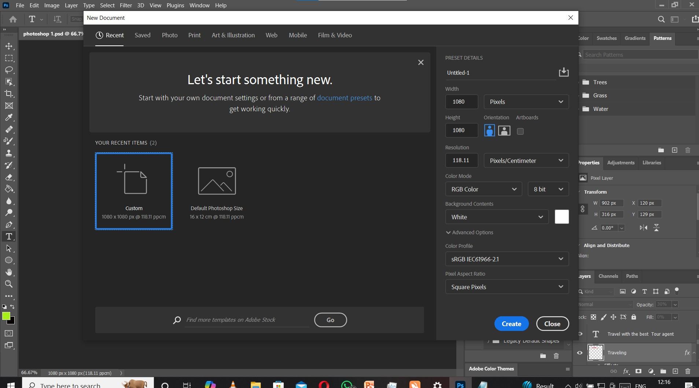

# 2. Choose a Background Image

* Import a high-quality image of the travel destination.
* Drag and drop it onto your canvas or use File > Place Embedded to insert the image.
* Adjust the size and position using the Transform tool (Ctrl + T or Cmd + T on Mac).

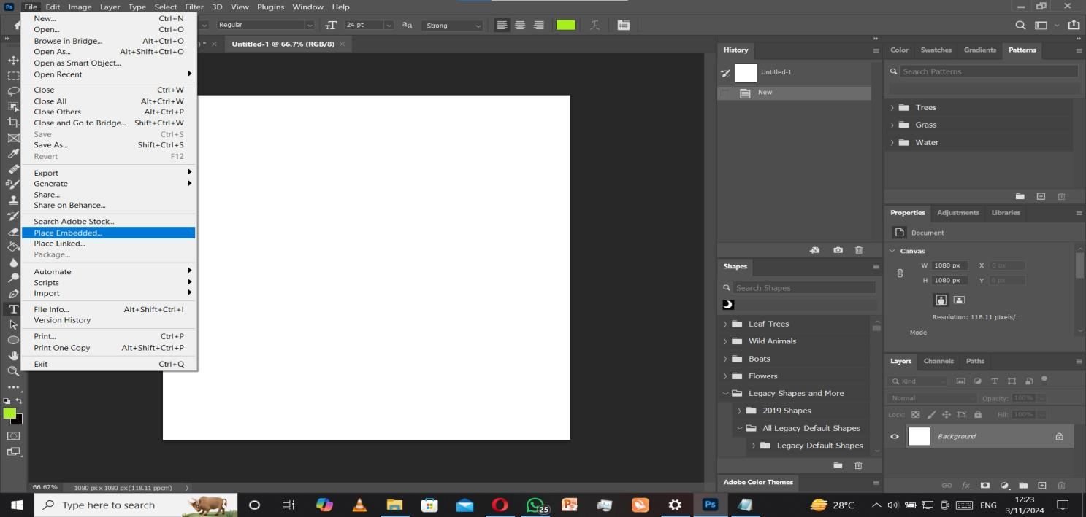

**3.Enhance the Background Image** • Adjust the brightness, contrast, and colors using Image > Adjustments to make the image pop.

* Use the Blur tool if you want to create depth by blurring the background slightly.

4. Add Typography

1. **Select the Type Tool** (T) to add text. Choose an attention-grabbing font for the main destination name.
2. Position the text strategically so it stands out but doesn’t obstruct key elements of the background image.
3. Customize the text:
   * **Color**: Pick a color that contrasts well with the background. o**Size**: Make the destination name large and readable from a distance.
   * **Effects**: Apply effects like drop shadows, strokes, or outlines for a bold look.

# 5. Add Secondary Information

1. Include relevant details like a travel slogan, dates, or website information in a smaller font.
2. Ensure this text is readable but doesn’t overpower the main destination name.

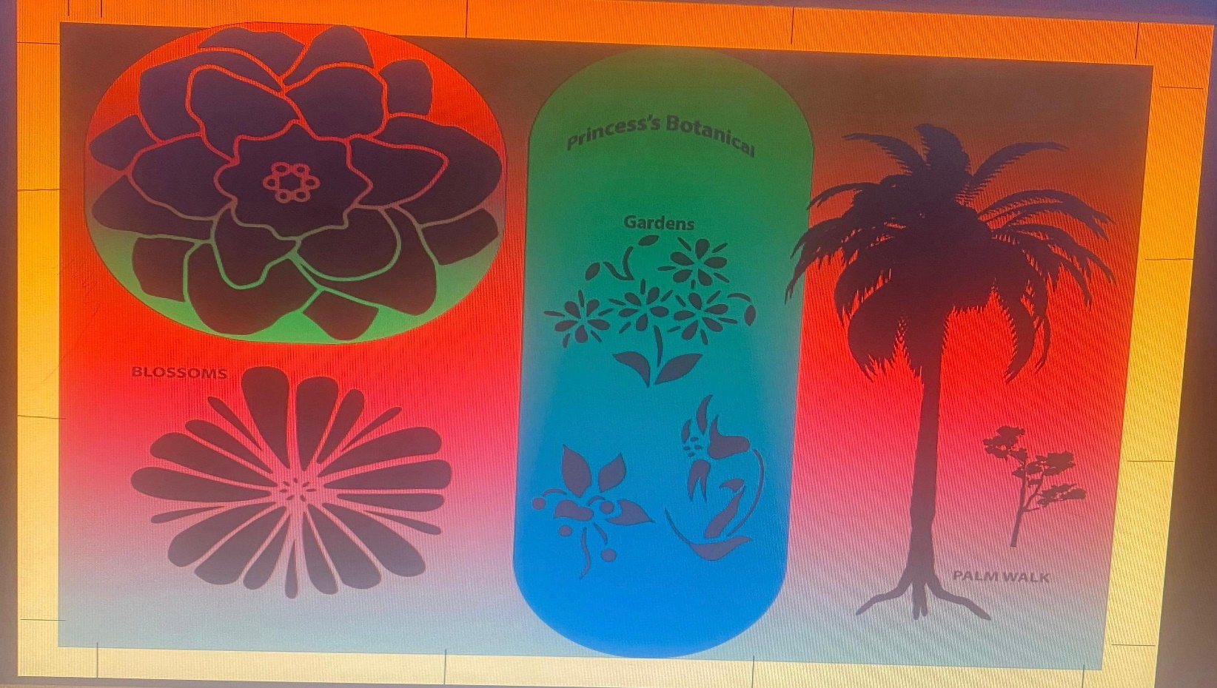

# 6.Final Adjustments

1. Apply any final **adjustments** to enhance colors and balance the composition.
2. Use the **Dodge & Burn tools** to add highlights or shadows, drawing attention to key areas.
3. Check your design for alignment and spacing to make sure everything looks clean and professional.

# 7.Save & Export

1. **Save your work** as a Photoshop file (.PSD) to preserve layers for future edits.
2. Export the poster:

oFor print: **File > Export > Export As** and choose .TIFF or .PDF format. oFor web use: Export as a .JPEG or .PNG with a reduced size if needed.

**Learning outcomes (What I have learnt):**

•**1.**Effective design starts with thoughtful planning and composition. Deciding on the layout, background, and text placement ensures that the final product communicates the message clearly and attractively.

1. Using color theory to create contrast between the text and background ensures readability and visual appeal.
2. Choosing the right fonts and applying text effects (like drop shadows or outlines) can significantly impact the design's tone and clarity.
3. : Adding shapes, icons, and textures helps to create a balanced design.
4. Experimenting with different elements, such as brushes, gradients, and textures, fosters creativity and encourages designers to think outside the box to make their work unique.

**Evaluation Grid:**

|  |  |  |  |
| --- | --- | --- | --- |
| Sr. No. | Parameters | Marks Obtained | Maximum Marks |
| 1. | Demonstration and Performance (Pre Lab Quiz) |  | 5 |
| 2. | Worksheet |  | 10 |
| 3. | Post Lab Quiz |  | 5 |